Diwali-analysis-data-science-project

[42]:
# import python libraries
import
numpy
as
np
#mathematical use
import
pandas
as
pd
#use for dataframe means tables
import
matplotlib
.
pyplot
as
plt
# visualizing data
import
seaborn
as
sns
#matplotlib and seaborn is use for making charts and
␣
↪
graphs
[43]:
# import csv file
df
=
pd
.
read_csv(
'
Diwali Sales Data.csv
'
, encoding
=
'
unicode_escape
'
)
df
[43]:
1002903
Cust_name Product_ID Gender Age Group Age \
0 1000732.0 Sanskriti P00125942 F | 26-35 28
1 1001990.0 Kartik P00110942 F | 26-35 35
2 1001425.0 Bindu P00118542 F | 26-35 35
3 1000588.0 Sudevi P00237842 M | 0-17 16
4 1000588.0 Joni P00057942 M  … … … … … … … | 26-35 28
11246 1004089.0 Manning P00296942 M | 18-25 19
11247 1001209.0 Reichenbach P00171342 M | 26-35 33
11248 1004023.0 Oshin P00201342 F | 36-45 40
11249 1002744.0 Noonan P00059442 M | 36-45 37
11250 NaN Brumley P00281742 F | 18-25 19
Marital_Status State Zone | Occupation \
0 0 Maharashtra Western | Healthcare
1 1 Andhra Pradesh Southern | Govt
2 1 Uttar Pradesh Central | Automobile
3 0 Karnataka Southern | Construction
4 1 Gujarat Western Food Processing
… … … … …
11246 1 Maharashtra Western Chemical 11247 0 Haryana Northern Healthcare
11248 0 Madhya Pradesh Central Textile 11249 0 Karnataka Southern Agriculture
11250 0 Maharashtra Western Healthcare
Product_Category Orders Amount Status unnamed1
- Auto 1 23952.0 NaN NaN
- Auto 3 23934.0 NaN NaN
- Auto 3 23924.0 NaN NaN
- Auto 2 23912.0 NaN NaN
- Auto 2 23877.0 NaN NaN
… … … … … …
- Office 4 370.0 NaN NaN
- Veterinary 3 367.0 NaN NaN
- Office 4 213.0 NaN NaN
- Office 3 206.0 NaN NaN
- Office 3 188.0 NaN NaN
[11251 rows x 15 columns]
[44]:
df
.
shape
[44]: (11251, 15)
[45]:
df
.
head()
[45]: 1002903 Cust_name Product_ID Gender Age Group Age Marital_Status \
0 1000732.0 Sanskriti P00125942 F 26-35 28 0
1 1001990.0 Kartik P00110942 F 26-35 35 1
2 1001425.0 Bindu P00118542 F 26-35 35 1
3 1000588.0 Sudevi P00237842 M 0-17 16 04 1000588.0 Joni P00057942 M 26-35 28 1
State Zone Occupation Product_Category Orders \
0 Maharashtra Western Healthcare Auto 1
1 Andhra Pradesh Southern Govt Auto 3

- Uttar Pradesh Central Automobile Auto 3
- Karnataka Southern Construction Auto 2
- Gujarat Western Food Processing Auto 2
Amount Status unnamed1
- 23952.0 NaN NaN
- 23934.0 NaN NaN
- 23924.0 NaN NaN
- 23912.0 NaN NaN
- 23877.0 NaN NaN
[46]:
df
.
info()
<class 'pandas.core.frame.DataFrame'>
RangeIndex: 11251 entries, 0 to 11250
Data columns (total 15 columns):
# Column | Non-Null Count Dtype
--- ------ | -------------- -----
0 1002903 | 11250 non-null float64
1 Cust_name | 11251 non-null object
2 Product_ID | 11251 non-null object
3 Gender | 11251 non-null object
4 Age Group | 11251 non-null object
5 Age | 11251 non-null int64
6 Marital_Status | 11251 non-null int64
7 State | 11251 non-null object
8 Zone | 11251 non-null object
9 Occupation | 11251 non-null object
- Product_Category 11251 non-null object
- Orders 11251 non-null int64
- Amount 11239 non-null float64 13 Status 0 non-null float64 14 unnamed1 0 non-null float64
dtypes: float64(4), int64(3), object(8)
memory usage: 1.3+ MB
[47]:
#drop unrelated/blank columns
df
.
drop([
'
Status
'
,
'
unnamed1
'
, axis
]
=
1
, inplace
=
True
)
[48]:
#check for null values
pd
.
isnull(df)
.
sum()
[48]:
1002903
1
Cust_name | 0
Product_ID | 0
Gender | 0
Age Group | 0
Age | 0
Marital_Status | 0
State | 0
Zone | 0
Occupation | 0
Product_Category | 0
Orders | 0
Amount | 12
dtype: int64
[49]:
# drop null values
df
.
dropna(inplace
=
True
)
#dropna delete null values
[50]:
#initialize list of lists
data_test
=
[[
'
Anushka
'
,
11
,
[
]
'
Kahna
'
,
15
]
,
[
'
Keshav
'
,],[
'
Lalita
'
,
16
]]
#create the pandas dataframe using list
df_test
=
pd
.
DataFrame(data_test,columns
=
[
'
Name
'
,
'
Age
'
])
df_test
[50]:
Name Age
  - Anushka 11.0
  - Kahna 15.0
  - Keshav NaN
16.0
Lalita
3
[51]:
# change data type
df[
'
Amount
'
]
=
df[
'
Amount
'
]
.
astype(
'
int
'
)
[52]:
df[
'
Amount
'
]
.
dtypes
[52]: dtype('int64')
[53]:
df
.
columns
[53]: Index(['1002903', 'Cust_name', 'Product_ID', 'Gender', 'Age Group', 'Age',
'Marital_Status', 'State', 'Zone', 'Occupation', 'Product_Category',
'Orders', 'Amount'],
dtype='object')
[54]:
#Remove spaces
df
.
columns
=
df
.
columns
.
str
.
strip()
[55]:
#rename column
df
.
rename(columns
=
{
'
Marital_Status
'
:
'
Shaadi
'
})
[55]:
1002903
Cust_name Product_ID Gender Age Group Age Shaadi \
0 1000732.0 Sanskriti P00125942 F 26-35 28 0

1 1001990.0 Kartik P00110942 F 26-35 35 1

2 1001425.0 Bindu P00118542 F 26-35 35 1

3 1000588.0 Sudevi P00237842 M 0-17 16 0
4 1000588.0 Joni P00057942 M 26-35 28 1
… … … … … … … …
- 1000695.0 Bertelson P00057442 F 26-35 31 1
- 1004089.0 Manning P00296942 M 18-25 19 1
- 1001209.0 Reichenbach P00171342 M 26-35 33 0
- 1004023.0 Oshin P00201342 F 36-45 40 0
- 1002744.0 Noonan P00059442 M 36-45 37 0

State Zone Occupation Product_Category Orders \

0 Maharashtra Western Healthcare Auto 1

1 Andhra Pradesh Southern Govt Auto 3
- Uttar Pradesh Central Automobile Auto 3
- Karnataka Southern Construction Auto 2
- Gujarat Western Food Processing Auto 2
… … … … … …
- Delhi Central Aviation Office 2
- Maharashtra Western Chemical Office 4
- Haryana Northern Healthcare Veterinary 3
- Madhya Pradesh Central Textile Office 4
- Karnataka Southern Agriculture Office 3
Amount
- 23952
- 23934
- 23924
- 23912
- 23877
… …
- 381
- 370
- 367
- 213
- 206
[11238 rows x 13 columns]
[56]: # describe() method returns description of the data in the DataFrame (i.e.␣
↪count, mean, std, etc) df.describe()
[56]: 1002903 Age Marital_Status Orders Amount
count 1.123800e+04 11238.000000 |  | 11238.000000 11238.000000 11238.000000
mean 1.003004e+06 | 35.411817 | 0.420093 | 2.489589 9454.435042
std 1.716159e+03 | 12.753494 | 0.493595 | 1.115006 5221.855974
min 1.000001e+06 | 12.000000 | 0.000000 | 1.000000 206.000000
25% 1.001492e+06 | 27.000000 | 0.000000 | 2.000000 5443.000000
50% 1.003064e+06 | 33.000000 | 0.000000 | 2.000000 8109.000000
75% 1.004430e+06 | 43.000000 | 1.000000 | 3.000000 12676.000000
max 1.006040e+06 | 92.000000 | 1.000000 | 4.000000 23952.000000
[57]: # use describe() for specific columns df[['Age', 'Orders', 'Amount']].describe()
[57]: Age Orders Amount count 11238.000000 11238.000000 11238.000000 mean 35.411817 2.489589 9454.435042 std 12.753494 1.115006 5221.855974
min | 12.000000 | 1.000000 206.000000
25% | 27.000000 | 2.000000 5443.000000
50% | 33.000000 | 2.000000 8109.000000
75% | 43.000000 | 3.000000 12676.000000
max | 92.000000 | 4.000000 23952.000000
1 Exploratory Data Analysis

1.0.1 Gender
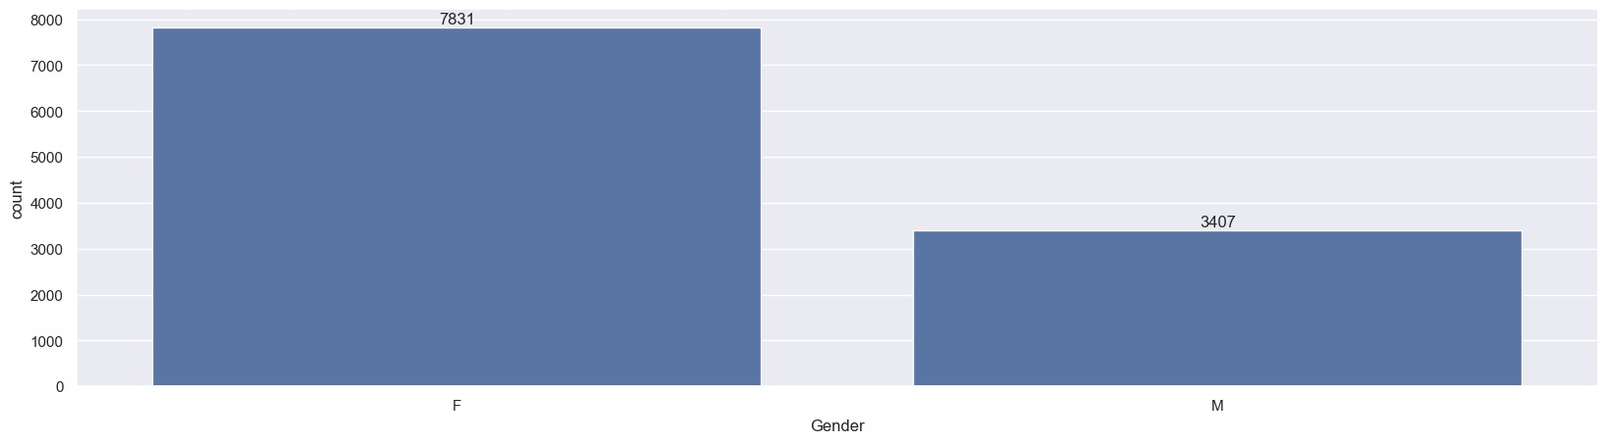
[58]:
# plotting a bar chart for Gender and it's count
ax
=
sns
.
countplot(x
=
'
Gender
'
,data
=
df)
for
bars
in
ax
.
containers:
ax
.
bar_label(bars)
[59]: # plotting a bar chart for gender vs total amount
sales_gen = df.groupby(['Gender'], as_index=False)['Amount'].sum(). ↪sort_values(by='Amount', ascending=False) sns.barplot(x = 'Gender',y= 'Amount' ,data = sales_gen)
[59]: <Axes: xlabel='Gender', ylabel='Amount'>
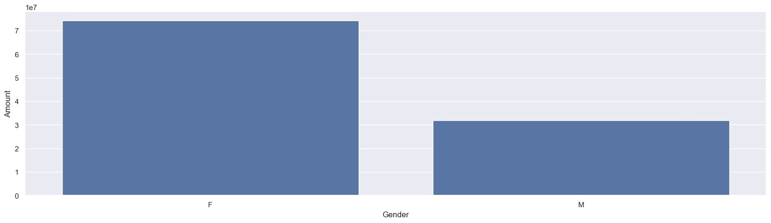
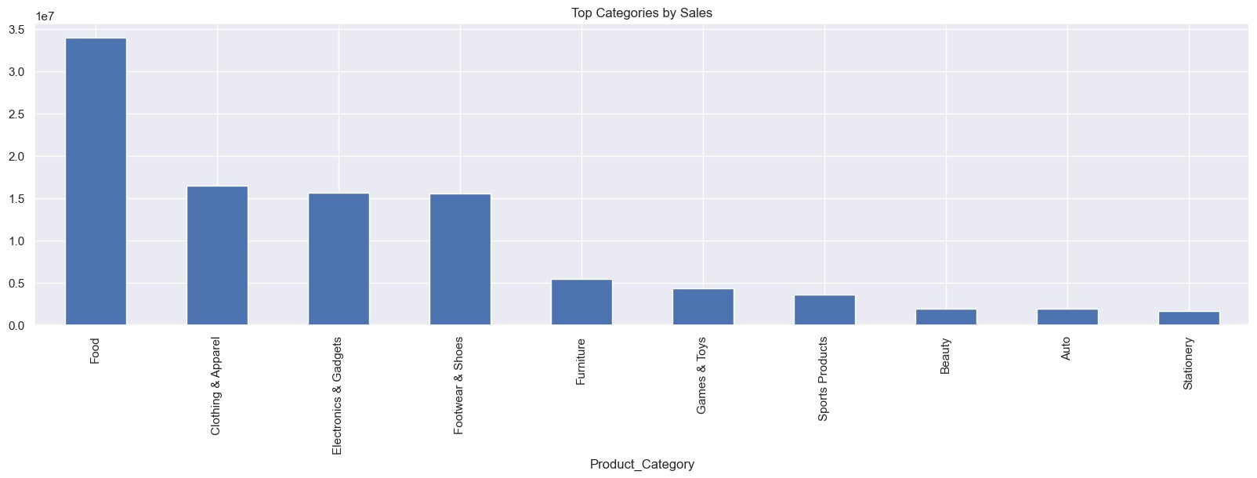
[60]:
# Category vs Amount
df
.
groupby(
'
Product_Category
'
)[
'
Amount
'
]
.
sum()
.
sort_values(ascending
=
False
)
.
↪
head(
10
)
.
plot(kind
=
'
bar
'
)
plt
.
title(
"
Top Categories by Sales
"
)
plt
.
show()
From above graphs we can see that most of the buyers are females and even the purchasing power of females are greater than men

1.0.2 Age
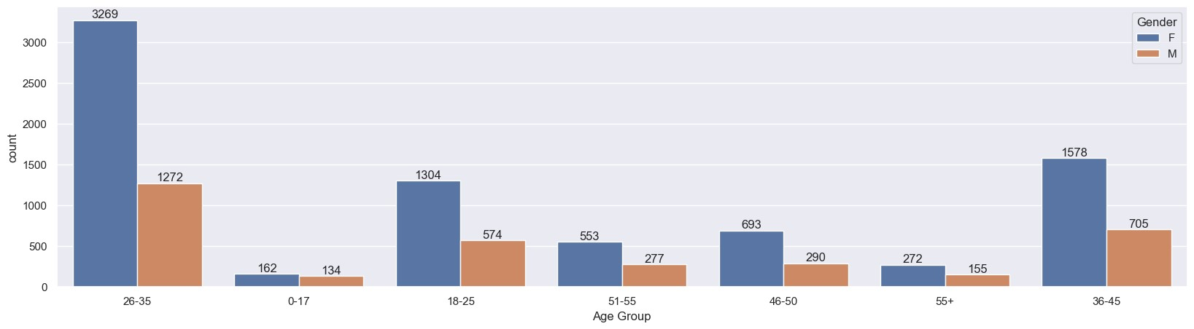
[61]:
ax
=
sns
.
countplot(data
=
df, x
=
'
Age Group
'
, hue
=
'
Gender
'
)
for
bars
in
ax
.
containers:
ax
.
bar_label(bars)
[62]:
# Total Amount vs Age Group
sales_age = df.groupby(['Age Group'], as_index=False)['Amount'].sum(). ↪sort_values(by='Amount', ascending=False) sns.barplot(x = 'Age Group',y= 'Amount' ,data = sales_age)
[62]: <Axes: xlabel='Age Group', ylabel='Amount'>
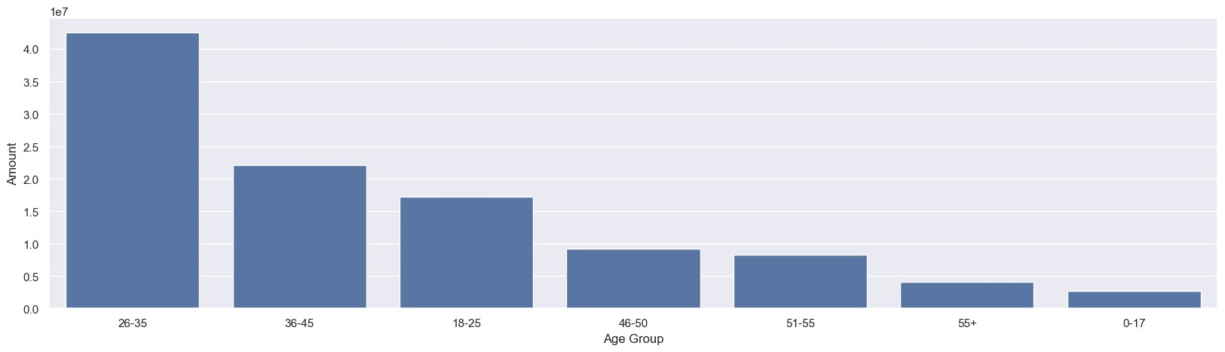
From above graphs we can see that most of the buyers are of age group between 26-35 yrs female

1.0.3 State
[63]: # total number of orders from top 10 states
sales_state = df.groupby(['State'], as_index=False)['Orders'].sum(). ↪sort_values(by='Orders', ascending=False).head(10)
sns.set(rc={'figure.figsize':(15,5)})
sns.barplot(data = sales_state, x = 'State',y= 'Orders')
[63]: <Axes: xlabel='State', ylabel='Orders'>
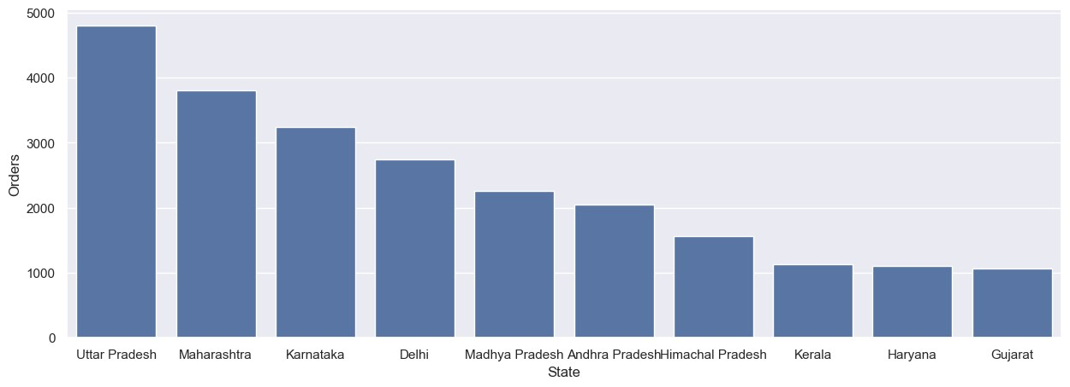
[64]: # total amount/sales from top 10 states
sales_state = df.groupby(['State'], as_index=False)['Amount'].sum(). ↪sort_values(by='Amount', ascending=False).head(10)
sns.set(rc={'figure.figsize':(15,5)})
sns.barplot(data = sales_state, x = 'State',y= 'Amount')
[64]: <Axes: xlabel='State', ylabel='Amount'>
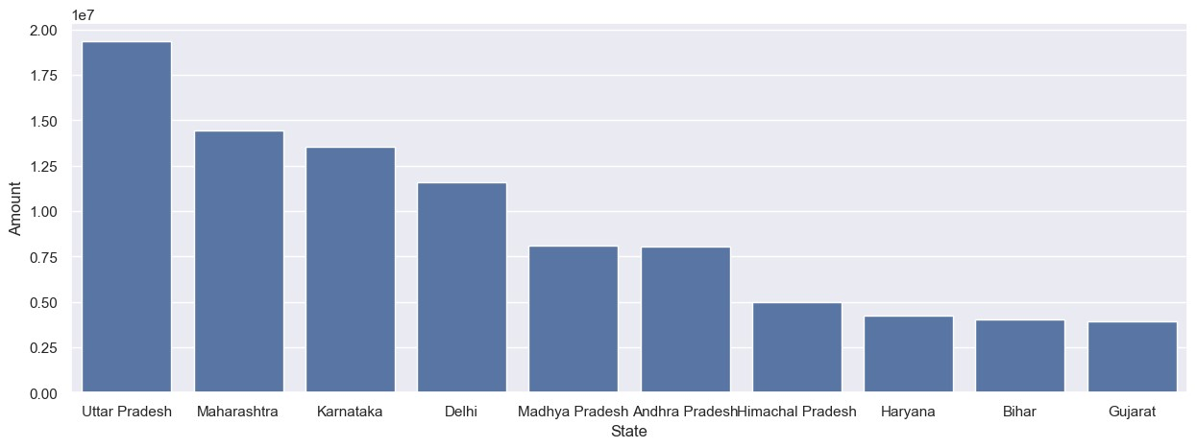
From above graphs we can see that most of the orders & total sales/amount are from Uttar Pradesh, Maharashtra and Karnataka respectively

1.0.4 Marital Status
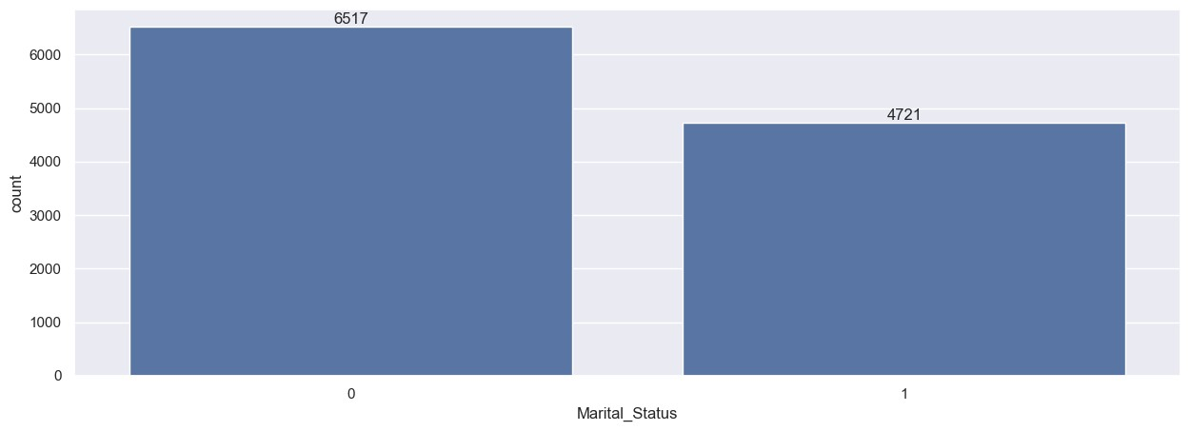
[65]:
ax
=
sns
.
countplot(data
=
df, x
=
'
Marital_Status
'
)
sns
.
set(rc
=
{
'
figure.figsize
'
:(
7
,
5
)})
for
bars
in
ax
.
containers:
ax
.
bar_label(bars)
[66]: sales_state = df.groupby(['Marital_Status', 'Gender'],␣
↪as_index=False)['Amount'].sum().sort_values(by='Amount', ascending=False)
sns.set(rc={'figure.figsize':(6,5)})
sns.barplot(data = sales_state, x = 'Marital_Status',y= 'Amount', hue='Gender')
[66]: <Axes: xlabel='Marital_Status', ylabel='Amount'>
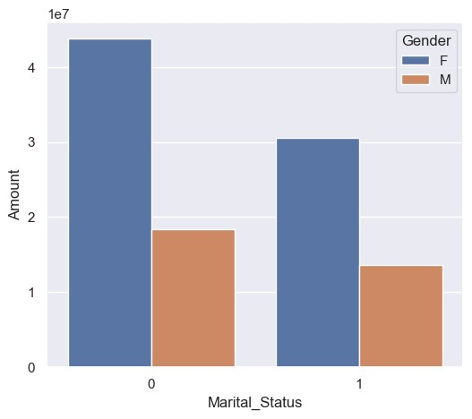
From above graphs we can see that most of the buyers are married (women) and they have high purchasing power

1.0.5 Occupation
[67]:
sns
.
set(rc
=
{
'
figure.figsize
'
:(
20
,
5
)})
ax
=
sns
.
countplot(data
=
df, x
=
'
Occupation
'
)
for
bars
in
ax
.
containers:
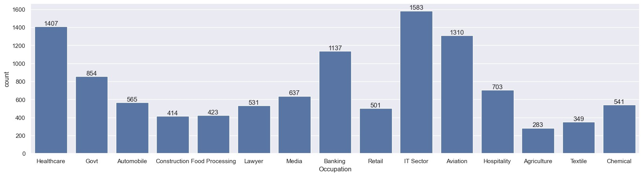
ax
.
bar_label(bars)
[68]: sales_state = df.groupby(['Occupation'], as_index=False)['Amount'].sum(). ↪sort_values(by='Amount', ascending=False)
sns.set(rc={'figure.figsize':(20,5)})
sns.barplot(data = sales_state, x = 'Occupation',y= 'Amount')
[68]: <Axes: xlabel='Occupation', ylabel='Amount'>
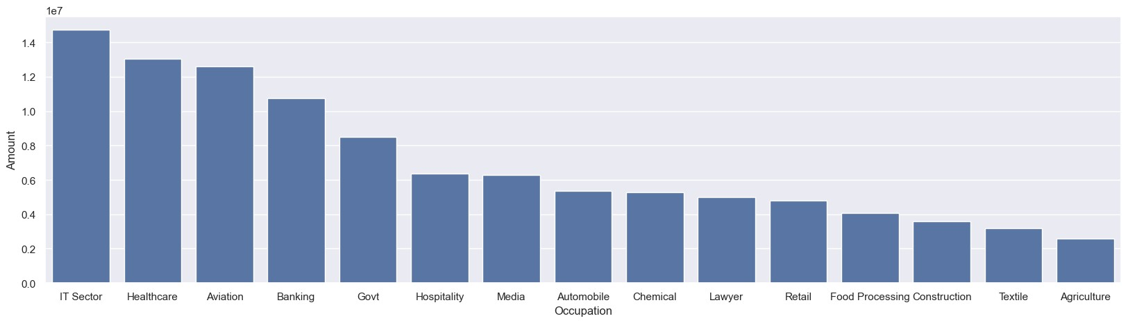
From above graphs we can see that most of the buyers are working in IT, Healthcare and Aviation
sector

1.0.6 Product Category
[69]:
sns
.
set(rc
=
{
'
figure.figsize
'
:(
20
,
5
)})
ax
=
sns
.
countplot(data
=
df, x
=
'
Product_Category
'
)
for
bars
in
ax
.
containers:
ax
.
bar_label(bars)
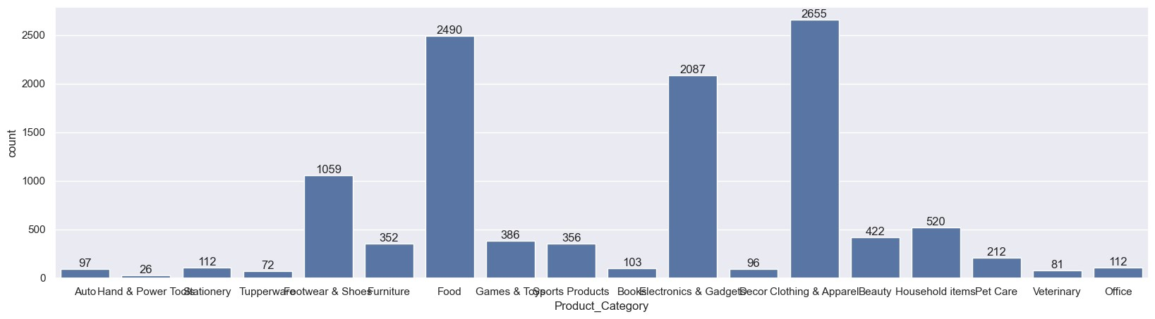
[70]: sales_state = df.groupby(['Product_Category'], as_index=False)['Amount'].sum(). ↪sort_values(by='Amount', ascending=False).head(10)
sns.set(rc={'figure.figsize':(20,5)})
sns.barplot(data = sales_state, x = 'Product_Category',y= 'Amount')
[70]: <Axes: xlabel='Product_Category', ylabel='Amount'>
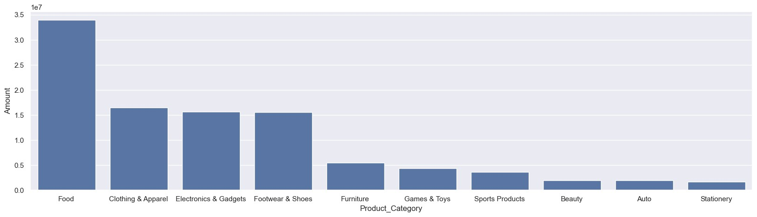
From above graphs we can see that most of the sold products are from Food, Clothing and Electronics category
[71]: sales_state = df.groupby(['Product_ID'], as_index=False)['Orders'].sum(). ↪sort_values(by='Orders', ascending=False).head(10)
sns.set(rc={'figure.figsize':(20,5)})
sns.barplot(data = sales_state, x = 'Product_ID',y= 'Orders')
[71]: <Axes: xlabel='Product_ID', ylabel='Orders'>
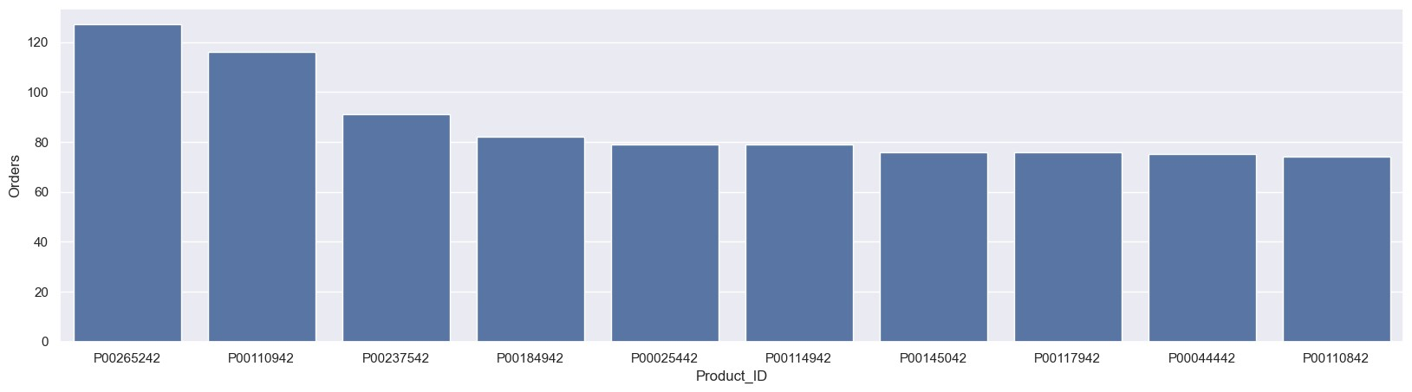
[72]: # top 10 most sold products (same thing as above)
fig1, ax1 = plt.subplots(figsize=(12,7)) df.groupby('Product_ID')['Orders'].sum().nlargest(10).
↪sort_values(ascending=False).plot(kind='bar')
[72]: <Axes: xlabel='Product_ID'>
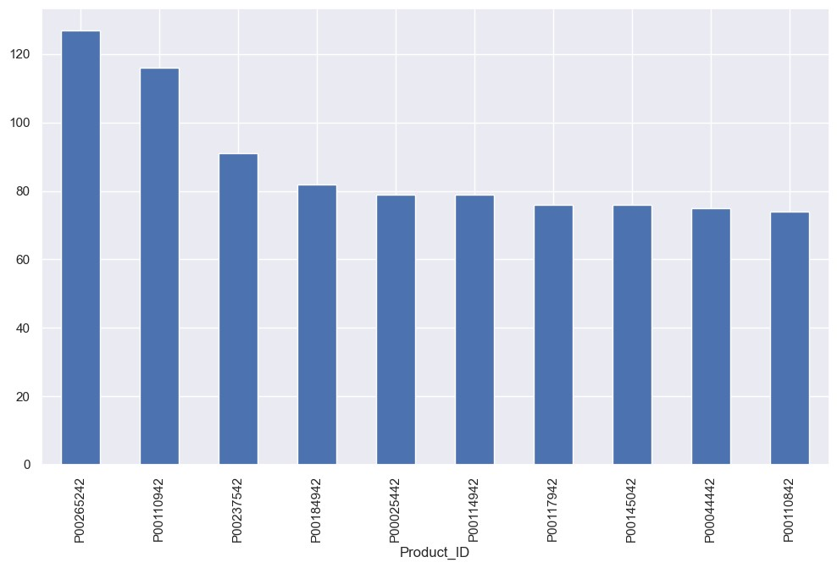
Encoding Categorical Data
[73]:
from
sklearn
.
preprocessing
import
LabelEncoder
le
=
LabelEncoder()
for
col
in
df
.
select_dtypes(include
=
'
object
'
):
df[col]
=
le
.
fit_transform(df[col])
df
.
head()
[73]: 1002903 Cust_name Product_ID Gender Age Group Age Marital_Status \
- 1000732.0 991 774 0 2 28 0
- 1001990.0 596 644 0 2 35 1
- 1001425.0 150 714 0 2 35 1
- 1000588.0 1102 1507 1 0 16 0
- 1000588.0 574 387 1 2 28 1
State Zone Occupation Product_Category Orders Amount
- 10 4 8 0 1 23952
- 0 3 7 0 3 23934
- 14 0 1 0 3 23924
- 7 3 5 0 2 23912
- 3 4 6 0 2 23877
Feature ENGINEERING
[74]:
# Example: If Qty column exists
# df['Total'] = df['Amount'] * df['Qty']
corr
=
df
.
corr()
plt
.
figure(figsize
=
(
10
,
6
))
sns
.
heatmap(corr, annot
=
True
)
plt
.
show()
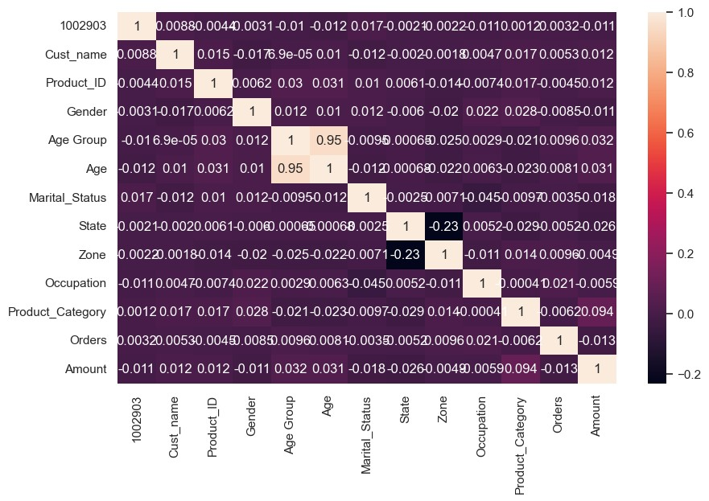
Machine Learning Predict Sales
[75]:
from
sklearn
.
model_selection
import
train_test_split
from
sklearn
.
linear_model
import
LinearRegression
from
sklearn
.
metrics
import
mean_absolute_error, r2_score
# Split data
x
=
df
.
drop(
"
Amount
"
, axis
=
1
)
y
=
df[
"
Amount
"
]
x_train, x_test, y_train, y_test
=
train_test_split(x, y, test_size
=
0.2
,
␣
↪
random_state
=
42
)
# Train model
model
=
LinearRegression()
model
.
fit(x_train, y_train)
# Predict
pred
=
model
.
predict(x_test)
# Evaluate
print
(
"
MAE:
"
, mean_absolute_error(y_test, pred))
print
(
"
R2 Score:
"
, r2_score(y_test, pred))
MAE: 4200.949470638929
R2 Score: 0.00541396696451113
CUSTOMER SEGMENTATION (K-MEANS)
[78]:
# Import required libraries
from
sklearn
.
cluster
import
KMeans
import
seaborn
as
sns
import
matplotlib
.
pyplot
as
plt
# Select variables for clustering
seg_data
=
df[[
'
Amount
'
,
'
Age
'
]]
# Create KMeans model
kmeans
=
KMeans(n_clusters
=
4
, random_state
=
42
)
# Fit and predict clusters
df[
'
Cluster
'
]
=
kmeans
.
fit_predict(seg_data)
# View first few rows
print
(
df
[[
'
Amount
'
,
'
Age
'
,
'
Cluster
'
]]
.
head())
# Visualize clusters
sns
.
scatterplot(x
=
'
Age
'
,y
=
'
Amount
'
, hue
=
'
Cluster
'
, data
=
df, palette
=
'
Set2
'
)
plt
.
title(
"
Customer Segmentation
"
)
plt
.
show()
Amount Age Cluster
- 23952 28 2
- 23934 35 2
- 23924 35 2
- 23912 16 2
- 23877 28 2
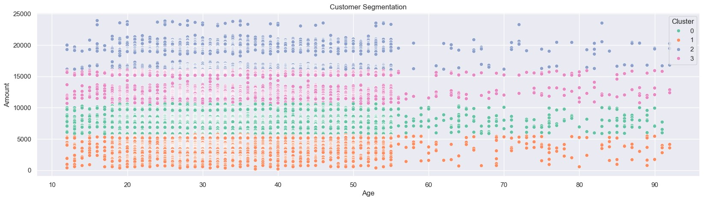
Total Sales by Product Category
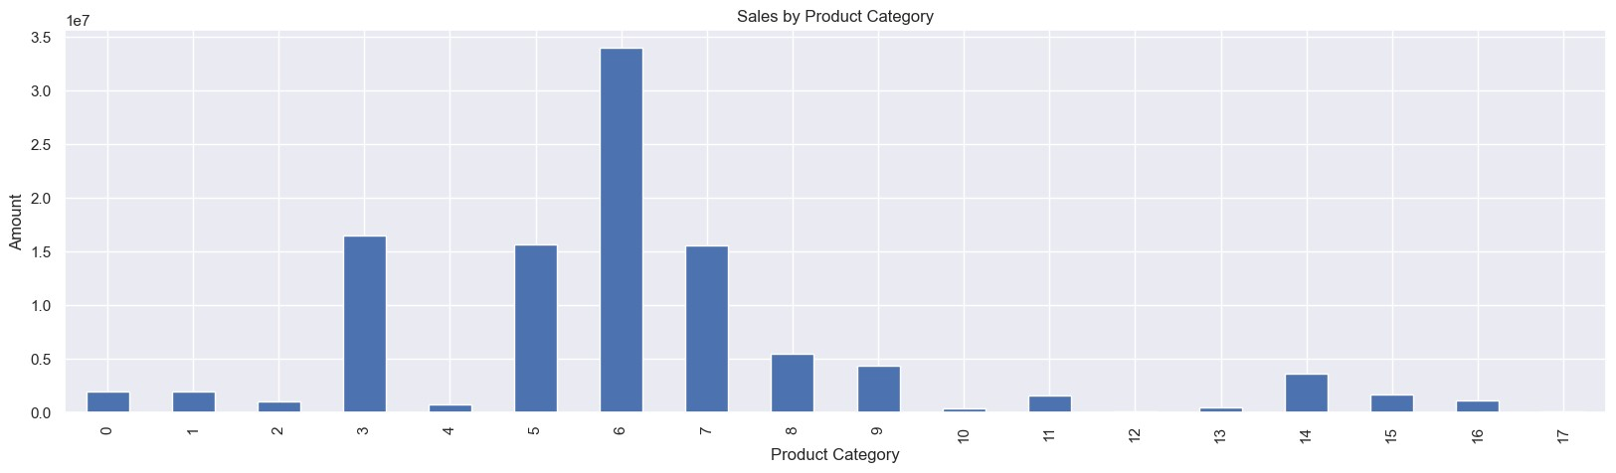
[88]:
import
matplotlib
.
pyplot
as
plt
df
.
groupby(
"
Product_Category
"
)[
"
Amount
"
]
.
sum()
.
plot(kind
=
"
bar
"
)
plt
.
title(
"
Sales by Product Category
"
)
plt
.
xlabel(
"
Product Category
"
)
plt
.
ylabel(
"
Amount
"
)
plt
.
show()
Sales by Gender
[89]: df.groupby("Gender")["Amount"].sum().plot(kind="pie", autopct="%1.1f%%") plt.title("Sales by Gender") plt.show()
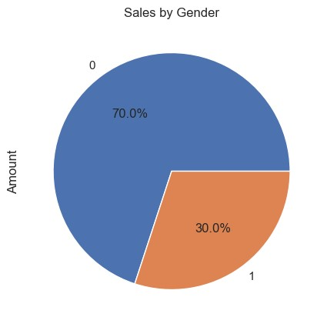
Sales by Age Group
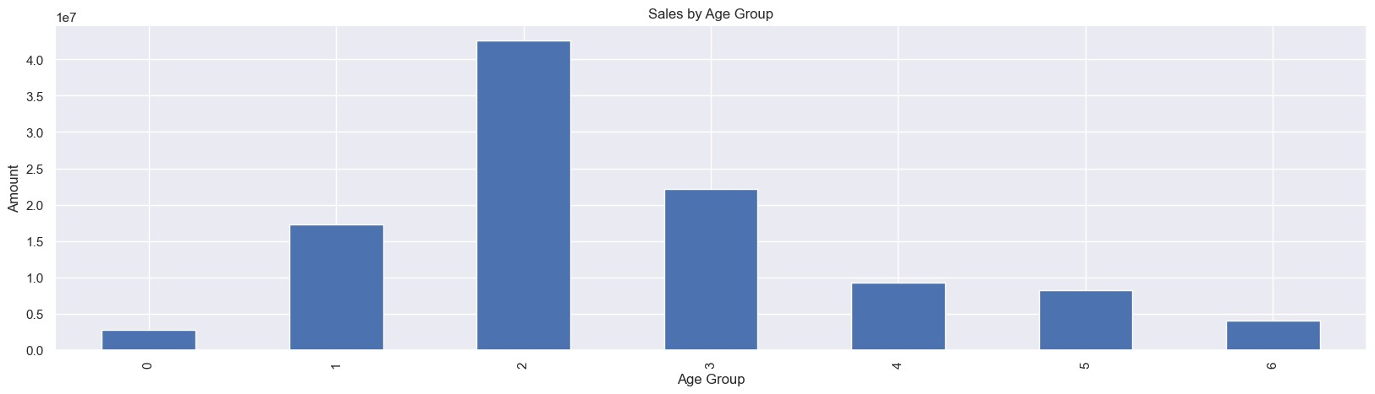
[90]:
df
.
groupby(
"
Age Group
"
)[
"
Amount
"
]
.
sum()
.
plot(kind
=
"
bar
"
)
plt
.
title(
"
Sales by Age Group
"
)
plt
.
xlabel(
"
Age Group
"
)
plt
.
ylabel(
"
Amount
"
)
plt
.
show()
Sales by State
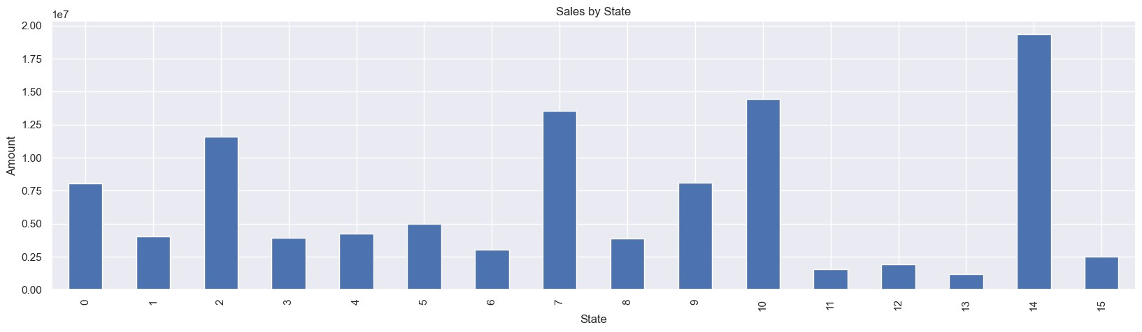
[91]:
df
.
groupby(
"
State
"
)[
"
Amount
"
]
.
sum()
.
plot(kind
=
"
bar
"
)
plt
.
title(
"
Sales by State
"
)
plt
.
xlabel(
"
State
"
)
plt
.
ylabel(
"
Amount
"
)
plt
.
show()
1.1 Conclusion:

1.1.1
Females contributed the highest to overall sales → Women purchased more frequently and spent more money compared to men. Targeting female customers can increase future sales.
2 Most buyers were from the age group 26–35 years → This group is the most active in festive shopping. Marketing campaigns should focus on young working professionals.
3 Maharashtra, Karnataka & Uttar Pradesh generated maximum revenue → These states show strong purchase behavior. Region-based offers & ad campaigns can further increase sales.
4 Top selling product categories were Clothing, Electronics & Household items → Most customers prefer spending on lifestyle & home improvement items during Diwali. These segments should be prioritized for inventory & promotion.
5 High-value customers contributed significantly to sales → Focusing on repeat premium buyers can increase retention & overall revenue. Overall Summary Diwali festival has a strong positive influence on sales. Female customers aged 26–35, especially from Maharashtra, Karnataka & UP, majorly drive the revenue. Clothing, Electronics & Household products remain the most profitable categories.
Thank you!

